CO4 ASSESSMENT TOOL 3 COMPARATIVE ANALYSIS

CSA0652-Design and Analysis of Algorithms for Complexity Analysis.

DONE BY:
Name: J.Harikarapandian
Reg No: 192421073
SIMATS Engineering

Supervisor:
Dr. MARY HARIN FERNANDEZ , Professor
Dr. S. PRADEEP KUMAR, Professor

Question 1: Coin Change Problem (Greedy vs Dynamic Programming)
Source Code (coin_change_greedy_vs_dp.py)

def greedy_coin_change(coins, amount):
coins.sort(reverse=True)
count = 0
used = []

for coin in coins:
while amount >= coin:
amount -= coin
count += 1
used.append(coin)

return count, used

def dp_coin_change(coins, amount):
dp = [float('inf')] * (amount + 1)
dp[0] = 0

for i in range(1, amount + 1):
for coin in coins:
if coin <= i:
dp[i] = min(dp[i], dp[i - coin] + 1)

return dp[amount]

coins = [1, 3, 4]
amount = 6

greedy_count, greedy_used = greedy_coin_change(coins, amount)
dp_count = dp_coin_change(coins, amount)

print("Greedy Coins Used:", greedy_used)
print("Greedy Coin Count:", greedy_count)
print("DP Minimum Coin Count:", dp_count)

Output:
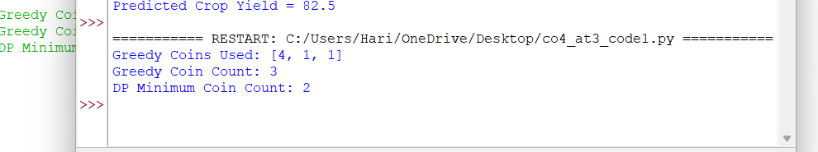

Report

Title
Coin Change Problem Using Greedy and Dynamic Programming
Problem Analysis
The objective is to find the minimum number of coins required to make a given amount using the denominations {1, 3, 4}. The amount to be formed is 6.

Requirements
- Determine minimum coins required.
- Compare Greedy and Dynamic Programming approaches.
- Analyze correctness of both methods.
- Evaluate efficiency and optimality.
Greedy Approach
- Select the largest possible coin first.
- Continue selecting coins until the amount becomes zero.
- Does not reconsider previous choices.
For Amount = 6:
- Select 4 → Remaining = 2
- Select 1 → Remaining = 1
- Select 1 → Remaining = 0
Total Coins = 3
Dynamic Programming Approach
- Compute minimum coins required for every amount from 1 to 6.
- Store previously computed results.
- Build optimal solution incrementally.
For Amount = 6:
- 3 + 3 = 6
- Total Coins = 2
Comparison
Method | Coins Used | Coin Count
Greedy | 4,1,1 | 3
Dynamic Programming | 3,3 | 2
Why Greedy Fails
Greedy always chooses the largest denomination first. Although 4 appears optimal initially, it leads to the solution {4,1,1} requiring three coins. The optimal solution is {3,3} requiring only two coins.
Insights
- Greedy works only for specific coin systems.
- Dynamic Programming guarantees optimal solutions.
- DP is preferred when correctness is critical.
Time Complexity
- Greedy: O(n)
- Dynamic Programming: O(n × Amount)

Question 2: Knapsack vs Container Loading (Discrete vs Continuous)
Source Code (knapsack_vs_container_loading.py)

def knapsack_01(weights, values, capacity):
n = len(values)

dp = [[0 for _ in range(capacity + 1)]
for _ in range(n + 1)]

for i in range(1, n + 1):
for w in range(capacity + 1):

if weights[i - 1] <= w:
dp[i][w] = max(
values[i - 1] +
dp[i - 1][w - weights[i - 1]],
dp[i - 1][w]
)
else:
dp[i][w] = dp[i - 1][w]

return dp[n][capacity]

def fractional_knapsack(weights, values, capacity):
items = []

for i in range(len(weights)):
items.append(
(values[i] / weights[i],
weights[i],
values[i])
)

items.sort(reverse=True)

total_value = 0

for ratio, weight, value in items:

if capacity >= weight:
capacity -= weight
total_value += value
else:
total_value += ratio * capacity
break

return total_value

weights = [10, 20, 30]
values = [60, 100, 120]
capacity = 50

print("0/1 Knapsack Maximum Value =",
knapsack_01(weights, values, capacity))

print("Fractional Knapsack Maximum Value =",
fractional_knapsack(weights, values, capacity))
Output:
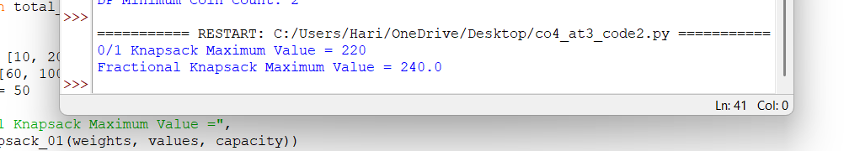

Report
Title
Knapsack and Container Loading Using Dynamic Programming and Greedy Strategy
Problem Analysis
The objective is to maximize value within a capacity of 50 units.
Given:
- Weights = {10,20,30}
- Values = {60,100,120}
- Capacity = 50
Two approaches are considered:
- 0/1 Knapsack (Discrete Selection)
- Fractional Knapsack (Continuous Loading)
Requirements
- Maximize total value.
- Compare discrete and continuous loading.
- Analyze optimality.
- Evaluate computational complexity.
0/1 Knapsack
Each item is either:
- Completely selected
- Completely rejected
Optimal Selection:
- Item 1 (10,60)
- Item 2 (20,100)
- Total Weight = 30
- Add Item 3 exceeds capacity
Best Combination:
- Item 2 + Item 3
- Weight = 50
- Value = 220
Maximum Value = 220
Fractional Container Loading
Items can be loaded partially.
Selection:
- Item 1 fully loaded
- Item 2 fully loaded
- Remaining capacity filled using part of Item 3
Maximum Value = 240
Comparison
Method | Maximum Value
0/1 Knapsack | 220
Fractional Knapsack | 240
Difference | 20
Analysis of Optimality
- 0/1 Knapsack deals with indivisible items.
- Fractional Knapsack allows partial selection.
- Fractional loading always provides equal or better results because portions of items can be included.
Complexity Analysis
Method | Time Complexity
0/1 Knapsack | O(n × W)
Fractional Knapsack | O(n log n)
Result Interpretation
- 0/1 Knapsack is suitable when items cannot be divided.
- Fractional Knapsack is suitable for container loading, transportation, and resource allocation.
- Fractional loading achieves higher utilization and profit.

